Department of Health Services  Timothy W. Lutz  Director |   County of Sacramento | Divisions  Administration  Behavioral Health  Primary Health  Public Health

Memorandum

Date: July 28, 2026

To: BHS Contracted Outpatient Providers and County Operated Programs

From: Monica Rocha-Wyatt, LMFT
Health Program Manager, Homeless and Housing Solutions

Subject: Update and Verification of SmartCare Special Population Designations and Problem List ICD-10-CM Z Codes for Members with a History of Chronic Homelessness

Purpose
This memo provides direction to all BHS Contracted Outpatient Providers and County-Operated Providers regarding documentation requirements for members receiving Behavioral Health Services Act (BHSA)- Housing Intervention benefits who have a current or historical experience of chronic homelessness.
Providers are required to review applicable member records to ensure:
- SmartCare Special Population designations are accurate.
- Appropriate housing-related ICD-10-CM Z Codes are documented on the Problem List.
- Documentation supports the member's history of chronic homelessness.
Accurate documentation is necessary to support State BHSA reporting requirements and ensure eligible members are appropriately counted toward BHSA Housing Intervention reporting.

Definition of BHSA Housing Intervention Benefit
For purposes of this memorandum, BHSA Housing Intervention benefit refers to housing assistance funded through the BHSA Housing Intervention component, including Permanent Supportive Housing (PSH) and other eligible housing supports authorized under State BHSA guidance.
The term does not refer to behavioral health treatment, rehabilitation, targeted case management, intensive care coordination, or other Specialty Mental Health Services.

Background
BHSA requires counties to demonstrate that at least 50% of funds distributed to counties for Housing Interventions must be used to support the housing needs of individuals who met the definition of chronic homelessness before, or at the time they began receiving BHSA Housing Intervention Benefits. For BHSA reporting purposes, individuals who met the definition of chronic homelessness before receiving BHSA Housing Intervention benefits continue to be counted after they become housed, provided they continue receiving eligible BHSA Housing Intervention benefits.
County review has identified members whose history of chronic homelessness has not been consistently documented within SmartCare. Providers are therefore required to review applicable records and update SmartCare documentation to ensure complete and accurate BHSA reporting.

Required Provider Actions
Providers must complete the following activities no later than August 12, 2026.

1. Review All Current Members
Review all members who were receiving BHSA Housing Intervention benefits on or after July 1, 2026, including members who were subsequently discharged after that date.
Determine whether each member met the definition of chronic homelessness before, or at the time they began receiving MHSA/BHSA Housing Intervention benefits by reviewing available documentation, including:
- Housing eligibility documentation
- Housing assessments
- HMIS records
- Case notes
- Collateral information
- Other supporting documentation.
Enrollment in a BHS PSH project that required chronic homelessness as an eligibility requirement may be accepted as documentation unless evidence indicates otherwise. These projects include:

  - Ardenaire
  - Martin Luther King Village
  - YWCA
  - Boulevard Court
  - Folsom Oaks
  - Mutual Housing at the Highlands
  - 7th and H
  - Studios at Hotel Berry
  - The Courtyards on Orange Grove
  - Los Molinos
  - Vista Nueva
  - Central Sacramento Studios
  - Mutual Housing on the Boulevard
  - Sunrise Pointe
  - Villa Jardin
  - St. Clare at Capital Park
  - Hope Landing
  - Powell’s Landing
  - Madison Square Studios
  - Sequoia

2. Update the Smart Care Special Population Designation
Update the Special Population field to accurately reflect the member's homelessness history.
Use the earliest date supported by available documentation. If an exact date cannot be determined, use the earliest reasonably supportable date.
Existing documentation within the member record or housing file is sufficient. New documentation is not required when adequate supporting evidence already exists.
For BHSA reporting purposes, members who met the definition of chronic homelessness before receiving BHSA Housing Intervention benefits continue to have a history of chronic homelessness while receiving those benefits.

Members currently experiencing chronic homelessness
- Select Homeless – Chronic.
- If applicable, also select Homeless – Living in an Encampment.
- Use the earliest supported date documenting chronic homelessness.

Members currently housed using BHSA Housing Intervention benefits
If the member met the definition of chronic homelessness before receiving BHSA Housing Intervention benefits and is currently housed:
- Continue the Homeless – Chronic Special Population designation.
- If the original chronic homelessness date cannot reasonably be determined, use the date the member began receiving BHSA Housing Intervention benefits as the start date.

Ending the designation
Enter an end date when the member is no longer receiving BHSA Housing Intervention benefits and is stably housed.
If the member later loses housing, reassess the member's homelessness status and update the Special Population designation, as appropriate.

SmartCare Instructions

How to determine a Special Population
Step 1: Open the client chart.
Step 2: Search for Special Populations (Client).
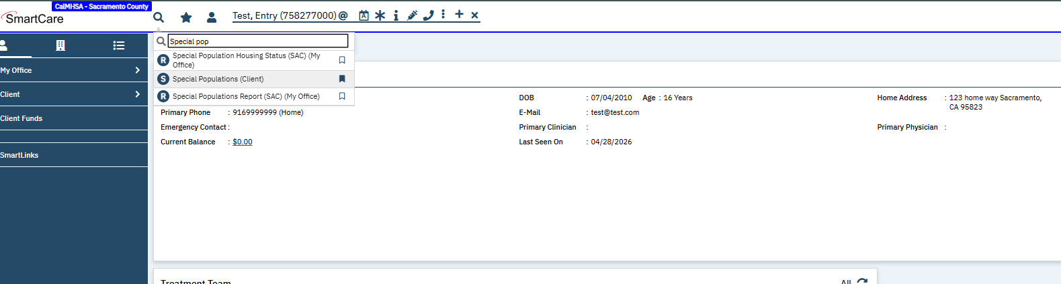
Step 3: Review existing Special Population entries
Step 4: Determine whether updates are needed.
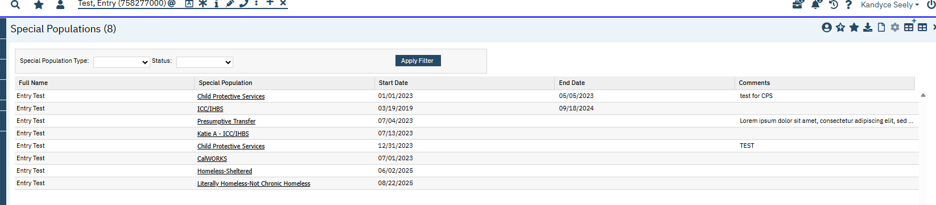

How to add or update a Special Population
Step 1: Open Special Populations (Client).
Step 2: Select New (page icon)
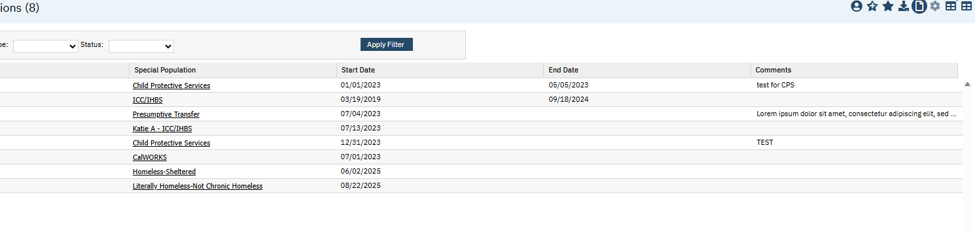
Step 4: Select the appropriate special population.
Step 5: Enter a start date.
Step 6: Save.
Step 7: Verify the new entry.
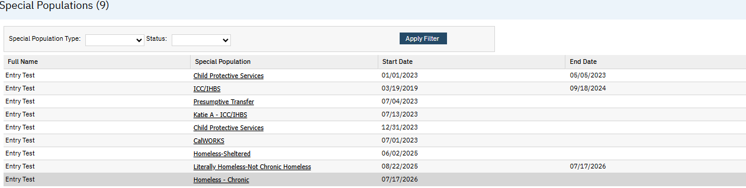

3. Update the Problem List
Ensure housing- related ICD-10-CM Z codes accurately reflect the member’s current housing status.
Housing status should be documented whenever a member:
• Is experiencing homelessness
• Is at imminent risk of homelessness
• Is experiencing housing instability
• Has recent homelessness history
Housing status must not be documented solely within demographic fields or narrative progress notes.
Current Situation | ICD-10-CM Z Code
Unsheltered homelessness | Z59.02
Sheltered homelessness | Z59.01
Imminent loss of housing (within 30 days) | Z59.811
Housing instability, details unclear | Z59.819
Recently homeless (past 12 months), currently housed | Z59.812

SmartCare Instructions
Step 1: Open the client chart.
Step 2: Open the Diagnosis Document.
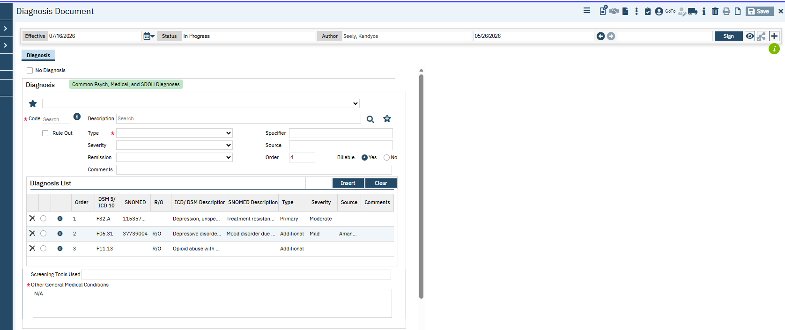
Step 3: Add or update the appropriate Z Code.
Step 4: Save.
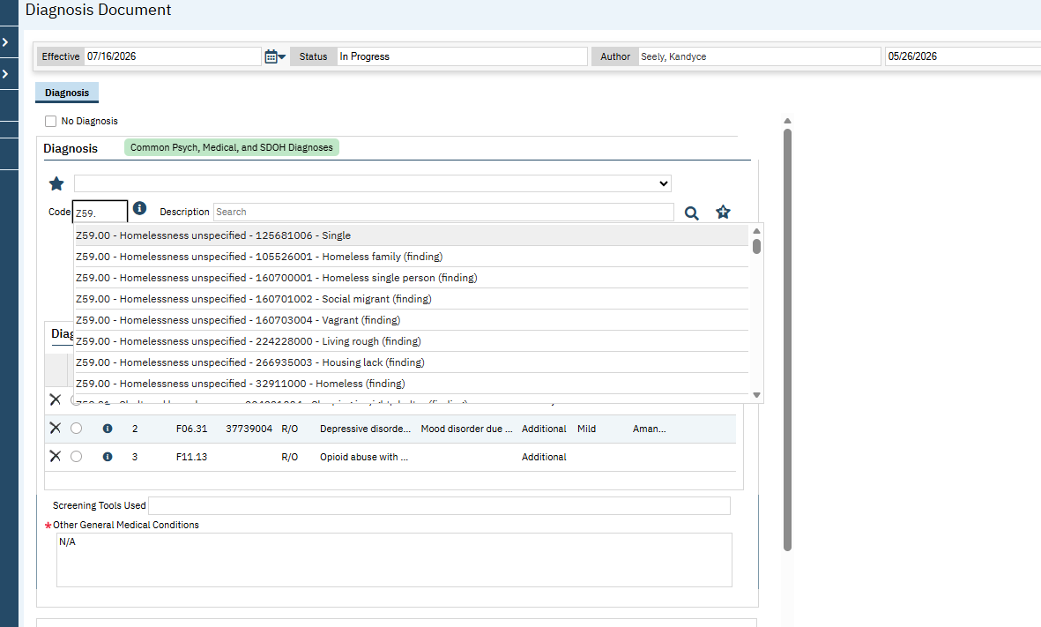
Step 5: Verify the updated Problem List.

4. Verify Supporting Documentation
Confirm the member record contains documentation supporting the chronic homelessness designation. Acceptable documentation may include:
- Case notes
- Housing assessments
- HMIS records
- Housing eligibility documentation
- Collateral information
- Reasonably verified member self-report.

5. Maintain Ongoing Data Accuracy
Whenever a member's housing status changes, providers must update:
- SmartCare Special Population designation
- Housing documentation
- Problem List Z Codes
Maintaining accurate documentation supports ongoing BHSA reporting requirements and helps ensure members continue to be appropriately counted for Housing Intervention reporting.

Technical Assistance
BHS Homeless and Housing Solutions will provide SmartCare guidance and technical assistance to support implementation of this memorandum.
Questions regarding this guidance may be directed to Rocha-WyattM@saccounty.gov.
Thank you for your partnership in ensuring accurate documentation and compliance with BHSA reporting requirements.

